The Google+ Business Blueprint

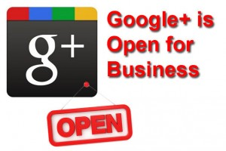

Introduction to the Google+ Guide

Launched in June 2011, Google+ is a new social network that is attracting some serious attention of marketers.

In just a few months, the platform has amassed 40 million+ users, nearly one third of LinkedIn’s 135 million membership base. Despite this impressive growth, the adoption of Google+ doesn’t yet compare to that of Facebook, which has more than 800 million users. But who knows what's going to happen next and can you afford to ignore it?

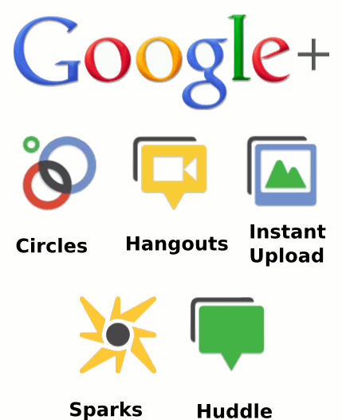

Ever since its launch, Google+ has been open to individuals to share stories with their Circles, get involved in discussions, post photos, and participate in video conference calls (called Hangouts).
However, the social network didn’t provide businesses with much value, and many marketers were left wondering how to truly benefit from Google+.

In early November, Google+ finally rolled out business pages. Now the platform not only enables companies to create pages, but also encourages businesses to grow their following. “I expect brands will notice this and will build marketing plans around it,” said Bradley Horowitz, vice president for products at Google+ in an article for The New York Times. His statement definitely reinforces the potential of the social network for marketing purposes.

Index

What Google+ is and why it Matters
- 9 Facts about Google Plus Pages and Your Business

How to set up a Google+ business page
- Choosing a type of page
- Customising your profile
- Promoting your page
- Hangouts
- Adding Google+ to Your Website
- List Building, Video Marketing
- Further Optimisation

The benefits of Google+
- 5 Ways Google+ Changes Search
- Improving Google Search
- Improved Search Results Quality
- Changing How You Get Traffic
- What’s the marketing takeaway for us as warriors
- Improved Click-Through Rates
- Direct Connect
- How to Set Up Google+ Direct Connect

Best practices for Marketing on google+
- Optimize Your Business Presence on Google+
- Share Lots of Photos
- Recommend Links
- Promote Your Google+ Page on Your Blog and Website
- Sharing Your Posts
- Analyze Traffic and Leads From Google+
- Use Circles to Communicate
- Hangouts and Ideas for Hangouts
- Pimping Out Your Pages
- Enable Google Analytics Integration for +1
- Communication

Conclusions

1. What is Google+ and Why Does It Matter

Google+ is a social network powered by the search engine giant Google. Many see this platform as a challenge to Facebook’s domination of the social media space. With more than 40 million users and a growing influence on search, Google+ has definitely emerged as a key player in the online marketing ecosystem.

Google’s equivalent to Facebook’s “Like” button, the “+1”, is about so much more than just social networking. It’s about enhancing your visibility on the biggest search engine in the world.

The business page concept will be very familiar to those who use Facebook Pages. Even the way you switch between personal and business profiles with a drop down menu is straight from Facebook:

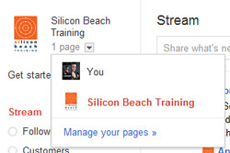

Google+ allows businesses to create pages and develop relationships with prospects and customers on multiple levels. Individuals can add a brand to a specific Google+ Circle, share a Google+ page with their network, and interact with the content posted by that company.

For instance, users can +1 (or in other words, endorse) the updates a company publishes, leave comments, upload photos, and tag the brand in them. An interesting aspect of this platform is that its Hangouts feature enables companies to engage with fans, prospects, and customers through video conference calls.

And how about this.

When one of my contacts +1’s one of your site’s pages, I see their endorsement in my search results when I search for products or services like yours. That provides a huge boost in terms of both credibility AND visibility — +1’d pages leap right out of the search results at you with a trusted face attached.

Video chat is definitely the element that distinguishes Google+ from other existing social networks.

“We want to help you make the same kinds of lasting connections with your customers online the way you can in real life,” wrote Dennis Troper, Product Management Director, Google+ Pages. Video communication is one way to make this happen.

9 Facts about Google Plus Pages and Your Business

- Pages can’t add people to Circles until the page is added first or mentioned.

- Pages can be made for a variety of different entities, whereas profiles can only be made for people.

- The default privacy setting for elements on your business page is public.

- Google+ Pages automatically unfollow you if you unfollow them.

- Pages can’t +1 other pages, nor can they +1 content on the web.

- Pages don’t receive notifications via email, text, or in the Google bar.

- Pages don’t have the option to share to ‘Extended Circles.’

- Local pages have special fields that help people find the business’ physical location.

- Google+ Pages can’t even mention you unless you’re connected.

A Quick Word About AdWords and AdSense

Along with the launch of Pages for Business, Google has launched a new extension to their AdWords service that will let people +1 your page right from your ad. Again , this is a way to help your ad stand out from the pack of generic text ads AND help your long term organic search visibility.

2. Set Up Your Google+ Page in 5 Easy Steps

While Google indicated that Google+ Pages wouldn’t be immediately accessible to all, they’re actually becoming readily available.

You are probably also eager to create a Google+ Page for your own business. The process isn’t difficult, and in this section, we will walk you through it step by step.

Before you start remember this:

- Your page name will be the title ( the name in the browser tab).
- Your page name + tagline will be the META description of the page.

1. Choose an Accessible Gmail Account

If we learned anything from creating our own page, it’s that Google+ Pages’ administrative capabilities could use improvement. Avoid creating your business page through just any old account, such as a personal gmail account.

Instead, choose a gmail account that is accessible to multiple members of your marketing team (e.g. companymarketingteam@gmail.com), and use that account to create your page.

Because Google+ Pages’ administrative capabilities currently aren’t as sophisticated as say, Facebook’s (which enable you to assign multiple page admins regardless of the page’s origins), you’ll want to choose a host account that makes your page as accessible to multiple contributors as possible.

The ‘Google+ Your Business’ Google+ Page has indicated that Google has already started working on multi-admin support and ownership transfer. For now, we recommend making your account as accessible to other team members as possible.

2. Create a Page With the Desired Account

Visit http://plus.google.com/pages/create, and if you see the option to create a Google+ Page, get started! Follow the wizard (it’s much like Facebook’s Page creation wizard), and choose the most appropriate option to classify your business.

The following screenshot shows the ‘Create a Page’ section of Google+. As you can see, there are five categories to choose from:

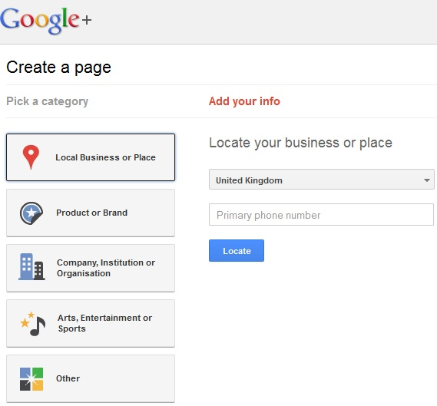

* Local Business or Place

* Product or Brand

* Company, Institution or Organization

* Arts, Entertainment or Sports

* Other

Local Business or Place – These are pages specifically designed so users can interact with a businesses physical location. Local businesses can add a phone number, opening hours and a map of their location will be automatically added to their business page.

Think this sounds awfully familiar to pages on Google Places? Well, it does. The key difference however is that G+ pages provides additional ways for businesses to interact and engage their audience, and this is really the point of social media marketing.

Product or Brand – These are pages specifically for products or brands such as cars, electronics or financial services for example. Administrators can choose the ‘Page name’, choose a category for their product or brand and define who the content is suitable for (18+, 21+, all Google+ users etc.). These pages can also be linked directly to the business homepage to help users find the G+ page more easily.

Company, Institution or Organisation – This is the same as the ‘Product or Brand’ create a page option, except it applies to companies, organisation, institutions and non-profits.

Arts, Entertainment or Sport – Again, the same options available except these pages are for films, music, TV, books, sports, shows etc.

Other – These can be used by businesses who don’t feel their page fits into one of the other categories.

The process of page creation is a fairly straightforward process, as can be expected from Google – but a key question is how can companies use their brand pages as a marketing tool, and specifically why would they use G+ pages over Facebook business pages?

After selecting your classification, fill in your basic information, including your page name (i.e. your company name), your business’ website URL, your category (i.e. your industry), and the classification of your page’s content (i.e. any Google+ user, 18 years of age or older, etc.).

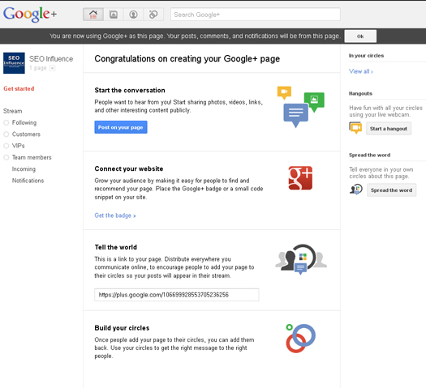

3. Customize Your Public Profile

The third step involves customizing your public profile. The profile basics include your tagline (think of it as your business’ elevator pitch) and an image (your company logo is a great option). Keep it concise, yet descriptive.

4. Promote Your Page

At this point, you’ve created the skeleton of your page, and Google+ will now prompt you to promote your page. Our recommendation is to customize your page even further and start sharing a few updates before you begin telling the world about it.

Promoting a blank page isn’t a great way to convince people that your page is valuable enough to add to their Circles. So invest some time into optimizing your page and sharing a few links to valuable content before you start promoting it to the masses.

5. Hangouts and stuff

Google have made it clear in their blog announcement that the reason they want brands to be represented on Google+ is for them to interact with their fans, customers or business partners. The most unique way to interact on Google+ is to conduct a ‘Hangout’, which is essentially a group video chat. This is something that has already been exploited by The Muppets, amongst others:

The Muppets have used it to raise awareness of their new film, scheduled for release at the end of this month. Using ‘Hangouts’ to conduct video chats with people is a great way to raise brand awareness and build a positive brand reputation across the web.

A company could, for example, host a ‘Hangout’ with their customers where they get to ask questions about products, services and competitions.

A company in a technical niche might choose to hold a weekly ‘Hangout’ where their followers can ask detailed questions and be confident they are getting an answer from an expert.

Companies could even us their ‘Hangouts’ to get suggestions from their followers about how they could perhaps improve their services. The point is that ‘Hangouts’ offer an unparalleled opportunity for brands and businesses to interact in real-time, face-to-face with the people that follow them. This really could be a fantastic opportunity for companies to really strengthen their brand reputation.

Again, this is something that online marketers can use as a more direct way of holding seminars etc. (More on this later)

6. Add the Google+ Badge to Your Website



Along with the release of Google+ Business Pages, Google have also launched the Google+ badge that can be added to your website to inform visitors that your company is active on Google+. To add the G+ badge:

- Copy your profile ID (this will be the number in the URL when on your profile page).
- Head over to the Google+ badge configuration tool and add your profile ID where prompted
- Choose one of the badges underneath and a code snippet will show.
- Copy and paste the code to a suitable position within your website’s source code.

Note. The choice of buttons is pretty lousy at the moment, but Google are promising some sexier ones soon.

So far the effects of adding the badge is vague, but knowing Google it can only help with SERPS, ranking and traffic.

7. Optimise Further

At the most basic level, this is really all you need to do to get your page launched. But as any smart marketer knows, the ‘basics’ aren’t usually enough. Intelligent marketers understand the importance of optimizing their page to make it not only more engaging, but also more valuable and effective for lead generation. In this step, follow Google+’s prompts to create an effective page, and remember -- Google+ is a social network.

Although every social network has its specific nuances and behaviors, many of the same best practices will still apply. Regularly share fresh content, react and respond to your fans, be engaging, and optimize for lead generation.

Then measure, adapt your strategy, and optimize your presence based on your own individual results and goals.

Don't Forget:

- Link your business page to your website – Useful link here

- Google also suggests you use the Google+ business page badge on your website find it here

- Don’t miss this opportunity to add relevant links to all of your other Social Media profiles, like Facebook, Twitter, YouTube etc. Include any affiliate or partner sites. You can add these in the “About Section” of your profile.

- You know the mantra “Content is king”, make sure you include your keywords whilst making sure it is clear, legible, accurate and useful. You can also add links to your introduction on your about page, but be careful to make them neat and relevant, you don’t want to come across as a link farm.

- Googles’ albums look beautiful. Make sure all your images are high quality, post good quality pictures regularly, they will show up in Google image search, give them keyword rich titles, tags and descriptions. this is a good place to share info-graphics about your niche.

3. Benefits of Google+ in Search

5 Ways Google+ Changes Search

Here are a few ways Google+ will influence how you will get traffic from Google’s search engine, whether by boosting your position in search results, increasing the chances that people will click into your site, or other factors.

1. Improving Google Search

As a result of Google+, Google will be able to improve its search engine results pages through the enhanced information it will be able to collect from your social circle.

Google+ offers a lot of elements that will allow Google to understand trends and what people are interested faster than ever before. Not only can they see what you share with your friends or what you are reading, but now they can also see which of your friends are most important to you.

In the past, they could have had a broad vision of your followers on Twitter, but now they can directly see exactly how you interact with those people. For example, do you frequently share links with only a small handful of people?

If you have a very tight relationship with a small network and a broader network that you are less engaged with, Google could know to promote your tight relationships in search results or use ads over the broad network.

Essentially, Google is getting deeper vision into how individual users share and discuss things on the internet. In the past, it had a limited vision of this. Now Google can own the complete picture. When placing recommendations on the results pages or looking for a certain page to promote, Google will now know which of your friends you trust and listen to the most.

Also, Google will have better insight into who your favorite authors are on certain blogs. If a blog has many authors and you tend to prefer a few of them or specific topics that the blog covers, Google can better adjust its rankings to show what you are interested in.

2. Improved Search Results Quality

Another benefit that Google+ brings to search is that results become much harder to cheat. Google can now more easily police who has a real profile and who is a spammer, and watch how they try to influence search results.

It's not for Spammers. But that's a good thing!

When Google sees a profile that only shares and votes for things on one website and nothing else, it knows who target as a spammer. If it sees profiles dominated exclusively by +1s, it might get suspicious. Let’s take this one step further.

If profiles are only following other profiles characterized by such behavior, Google might consider them suspect. Less gaming in Google’s results is a long-time goal for the search engine giant. Some spam sites are trying to sell +1 votes already, but it is unlikely to be worthwhile- -Google can easily watch for profiles that do nothing but spam votes and discount the value of those votes.

TIP: For that reason, I'd suggest you avoid buying Google+ Like gigs on sites like Fiverr.

3. Changing How You Get Traffic

Google also rolled out its version of the tweet or share button, the +1. These +1 buttons appear in Google’s search results and can be embedded on other websites as well. They are tied to a destination page address, just like shares or tweets are.

The +1 count that is displayed on each button is based on the address of the page where it sits. This detail is really important to be aware of, because this may influence how you design your website.

If you’re creating landing pages for paid search campaigns, and your pages have several variations, all of the +1 votes that you earn will be broken down separately for each page address.

Also, be aware that the number of +1 votes you have for a specific page can affect its Quality Score, which is critical when working on a budget for your paid ads. This isn’t a huge problem, but it’s important to be aware of.

Every time you move a page or change the address of something, you’ll be resetting the +1 count for that page.

4. Improved Click-Through Rates

The fourth major factor here, which is an often forgotten attribute to SEO success, is click-through rate, or how often people who see you on their results page actually click on your page in the results.

One of the powerful ideas behind the +1 votes is that if you can see that certain results are extremely popular, or that people found a specific resource particularly helpful, you have that information available without even clicking into the site.

You can see how many people have already found a certain page useful before you ever click or read any other details about it. This is similar to what Twitter and Facebook have given us access to with some of their customized buttons that reveal numbers of times something has been shared.

It's still very early but some of the testing I've tried unearthed interesting data around social sharing.

I'd suggest there's a powerful “first post” effect that marketers can leverage. In other words, people might be more willing to share a piece of content if they have a chance to be one of the first people to spread the word. In any case, now Google+ gives us more opportunities to speculate about social proof and its effect on social and viral behaviour online.

The access to this insight will strongly encourage searchers to click on specific “good” pages and ignore ones that are not as popular with their readers. If you’d like to see an example of how this can work, look at your Google Webmaster Tools dashboard. Google provides a chart to show your click-through rate with and without +1 results in the search results.

For example, in the diagram from Google below, you can see that people who saw a page in the search results with +1 information next to the website’s homepage were substantially more likely to click on our link. This is great reinforcement for us to place +1 buttons across our site, so that all of our pages can take advantage of the improved click-through rate!

As you can see, Google+ is not just like any social network out there. It has the power to affect our search habits, and the search engine giant is not afraid to use that to its advantage to penetrate the social media space.

While here we covered most of the important ways in which Google+ will affect search results, there is one more element that needs to be discussed. With the launch of Google+ Business Pages, Google also rolled out an interesting new integration between Google+ and Google search. The name of this integration is Direct Connect, and in the next section, we will discuss what it does and how to set it up.

5. Direct Connect +

How to Set Up Google+ Direct Connect

Google have added a feature to Google search in which adding a ‘+’ when searching for a brand will bring up their Google+ business profile. This doesn’t yet work for all pages and so might take a while to become fully functional.

Users who want to find a company’s Google+ page can now simply add a “+” in front of the company name in Google.com search to go directly to a company’s Google+ Page and skip over the traditional search engine results page.

In order to enable this awesome new “+” search operator to work for your business, you first need to install the Google+ Direct Connect code on your business’ website to help verify that your Google+ page is the “official” page for your business.

To do this, go to your Google+ page, and click the “connect your website” link under the “Get Started” section. Once you have done this, you will be taken to a screen that gives you options for six different Google+ buttons.

One of your options is also to display no button and just install the Google+ Direct Connect code on your website. That said, don’t you want people to connect with you on Google+? So go ahead and use one of the buttons to turn website visitors into Google+ Page subscribers!

Once you add the code to your website, you will be eligible to be included in Google Direct Connect.

But keep in mind that this doesn’t happen automatically. Google has stated it will be using an algorithm to determine which companies get included.

Make sure you are promoting your Google+ Page on your website, blog, and other properties off of Google+ in an effort to help influence the Direct Connect algorithm and get your business listed.

4. Best Practices for Marketers on Google+

- What’s the marketing takeaway for us as warriors?

Truth is, I haven't a clue.
But I know there's plenty to be excited about.

For example the Circles feature could replace traditional listbuilding, and the Hangouts video conference feature will surely revolutionise the webinar scene forever.

And then there's the social sharing buttons potential.
While this may sound obvious, many businesses still overlook the value of social sharing buttons and don’t use them effectively. Social sharing buttons serve two important purposes. First, they make it super easy and quick for a visitor to share your content on social media sites.

Plus, social sharing buttons act as a call to action on your blog that helps remind visitors that their online connections might be interested in the content as well.

I mentioned this before, but its value cannot be emphasised enough, so here it is again.

Very Important!

When one of my contacts +1’s one of your site’s pages, I see their endorsement in my search results when I search for products or services like yours. That provides a huge boost in terms of both credibility AND visibility — +1’d pages leap right out of the search results at you with a trusted face attached.

If you aren’t yet using the Google +1 button on your website, it’s definitely time to start.

For List Builders

The potential of Google+ for list builders and online marketers is massive. In effect it offers us the chance to bypass the endless emails, validation and subscription issues and communicate directly with mailing lists, simply by offering them incentives to follow us on Google+.

Just think about that for a minute.

No opt-in pages, no complicated set-ups or wasted effort creating complicated campaigns, just direct contact with your contacts and 'followers'.

Seminars, Web Conferences and Broadcast

With Google+ you can hold video meetings, seminars and conferences with your followers, without the need for third party software or websites.

How to Optimize Your Business Presence on Google+

Google+ is similar to other social networks when it comes to marketing, but it does have its own strengths and weaknesses. To get the most from your Google+ Business Page in terms or traffic and leads for your business, follow these best practices:

1. Share Lots of Photos

Photos are very important on Google+. A quick look at a Google+ feed will tell you that lots of individual images are shared by users. This is slightly different from Facebook, where users might upload an entire album of images at one time. Think about your business and marketing visually. Which images, charts, or slides can you share on Google+ to ignite conversations and increase the viral spread of your content? Google+ is built for sharing

2. Recommend Links

Under the ‘About’ tab of your Google+ Page, you have the option to add recommended links in the right side bar. Don’t let this space go to waste. Instead, add links to important blog articles and lead generation offers to drive more traffic and leads for your business.

3. Promote Your Google+ Page on Your Blog and Website

To get real business value from Google+, you have to have a community of people there to consume and engage with your content. In order to get people to add your Google+ Page to their Circles, you need to promote the page in places where you are already attracting visitors, such as your homepage, blog side bar, or other social media accounts. Cross-promotion is key to building a strong Google+ community.

4. Encourage People to Share Your Posts

Sharing on Google+ is a catalyst for increasing the virality of your content. When you post a message, photo, or link on Google+, be sure to ask your subscribers to share your content with the people in their Circles.
This is similar to asking people to “please retweet” on Twitter.

5. Analyze Traffic and Leads From Google+

So is this Google+ thing actually working for your business? To determine this, you’ll need to look at the traffic and leads that have been driven from Google+. You can do this by looking at referral traffic from plus.Google.com to your website.

6. Use Circles to Communicate

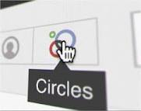

You must be thinking, “Why do we need yet ANOTHER social network?” Frankly, that is a reasonable question to ask. As you’ve read through this ebook, you have learned some of the reasons Google wants the platform to be successful: search.
What about users? Why would someone want to use Google+ as an individual user?

7. Hangouts
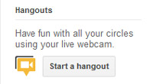

Hangouts and the ability to collaborate easily with others is cool, but arguably the biggest selling point of Google+ is Circles. Unlike other social networks, Google+ was built with the unique idea that different groups of people prefer different content.

Think about it this way. The same messages you share with your family might not be the same messages you want to share with your boss at work.

The Muppets have used Hangouts to raise awareness of their new film, scheduled for release at Christmas.

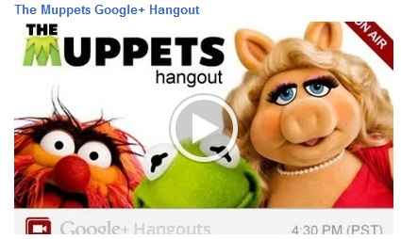

Using ‘Hangouts’ to conduct video chats with people is a great way to raise brand awareness and build a positive brand reputation across the web. A company could, for example, host a ‘Hangout’ with their customers where they get to ask questions about products, services and competitions.

A company in a technical niche might choose to hold a weekly ‘Hangout’ where their followers can ask detailed questions and be confident they are getting an answer from an expert.

Companies could even us their ‘Hangouts’ to get suggestions from their followers about how they could perhaps improve their services.

The point is that ‘Hangouts’ offer an unparalleled opportunity for brands and businesses to interact in real-time, face-to-face with the people that follow them. This really could be a fantastic opportunity for companies to really strengthen their brand reputation.

4 Ideas for Hangouts

- Q+A sessions with customers - allowing them to pose questions to a human face enhances consumer trust in a brand as they know they aren’t receiving an automated reply.
- Competitions – set up a competition in which you pose a question during a hangout and you could drive a huge amount of traffic onto your page at once.

- Employee meetings – one default business page circle is ‘team members’, by ensuring all your team members are part of this circle you can use hangouts for cross-department meetings and as an alternative to finding a meeting place.

- Client meetings – Many businesses already use hangouts to connect with clients and hold face-to-face meetings without being in the same room. By setting these up through a company profile instead of a personal profile the process becomes more professional.

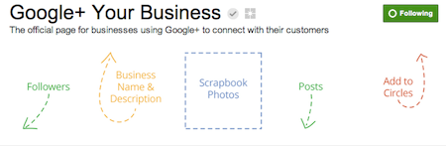

Pimping Out Your Pages

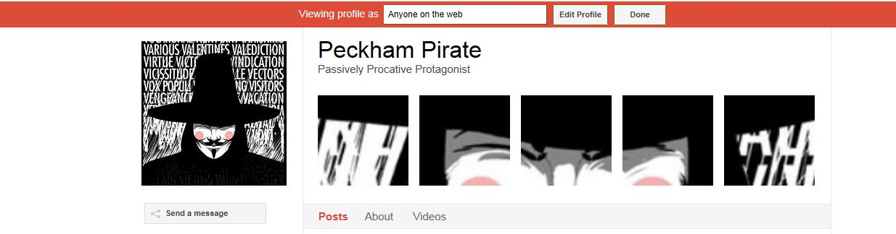

So far the art of pimping your Google+ Pages is still right in its infancy and there's not much available.

But just like Twitter and Facebook, moving forward, pages that look good and include additional graphics or links will stand out from the crowd and have more impact.

A couple of the options avalaible right now allow you to create a banner (like mine in the picture above) and customise the like 'buttons' you post around your web properties.

There are already a few sites which offer this free, and they're well worth a look.

http://gplusbanner.com/
http://gpluspic.com/
http://gpluslogo.com/

Keep an eye on these, as other G+ service providers are sure to advertise new products as they appear.

7. Enable Google Analytics Integration for +1

If you’re a Google Analytics user, you can also enable Google Analytics integration. All of your clicks will be added to a specified category in Google Analytics so you can check out how many clicks you’re getting on your +1 button.

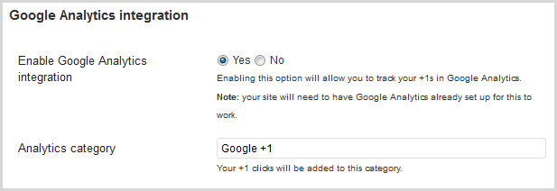

Along with the launch of Pages for Business, Google has launched a new extension to their AdWords service that will let people +1 your page right from your ad. Again , this is a way to help your ad stand out from the pack of generic text ads AND help your long term organic search visibility.
Another prediction: As the Google Plus platform grows, you’ll be able to target your AdWords ads to people based on their interests and employment as well as by what they’re searching for and where they’re located. This puts your products and services in front of your ideal customer at the precise moment they’re looking to buy. Powerful.

8. Segmenting your Communication

Google+ solves this problem by using what it calls Circles. Circles are no more than groups of people that users can create and label. For example, you might have different Circles for friends, family, and coworkers, and you would place new connections into their respective Circle. And yes, people can be added to more than one Circle.

Once you have Circles created, you can then decide to share a Google+ message with one or multiple Circles.

Segmentation is critical for organizing life online today. Organize your online life with Google+. Create the Circles you need to properly communicate with all your different business contacts.
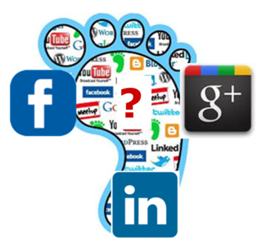

Conclusions

Google+ vs Facebook for Business

With the exception of ‘Hangouts’, the business pages on Google+ really do look similar to that on Facebook, and they seem to provide the same opportunity for updating followers on news, offers, competitions and other relevant information.

The same basic rules apply to Google Plus Pages as to other social networking platforms. Is your audience there and is it likely to be? Can you make the commitment to publish, share and interact?

The main differentiation would relate to the Google+ ‘circle’ model of sharing. Theoretically, businesses on Google+ could use ‘Circles’ to specifically target a certain group of followers with unique content; however, it might be difficult for particularly large brands with many followers to ensure that this system works effectively.
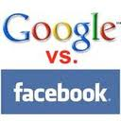
Google+ has seen the initial surge in users ease off in recent months, but now opening their doors to brands could provide another surge of momentum to further close the gap on Facebook. The question still remains as to whether users, SEOs and social media marketing executives will see enough value in G+ to start using it or representing their clients on it as well as Facebook.
With news emerging that it’s now possible to link a Google+ profile with an AdWords account, there will certainly be more developments as more businesses take to G+.

Google really hopes this update to their social network will encourage more people to join. The pages are a nice addition, but they don’t really offer anything better than what Facebook is already providing. This could be the downfall of Google+ as many social networking addicts are reluctant to switch from a platform they are comfortable with. The ability to directly connect with other business pages in your industry is something nice that Facebook cannot provide, but it might not be enough to convince the majority of social media users to switch services.

Having read this ebook, you are now aware of the many aspects in which Google+ will impact marketers.

The truth is, there will undoubtedly be a lot more features coming to the social network. Dennis Troper shared that Google has received some great feedback on Google+ Pages already and will be working on providing even more features soon.

So what is coming to Google+ Pages next?
“A few of the top requests [are ones that] we’ve already started working on, such as multi-admin support, ownership transfer, and page analytics,” wrote Troper. These are definitely popular features that are indispensable from a marketing perspective. What's more, Facebook already offers the ability to add multiple admins and to gain insights around sharing.

No doubt, Google will keep investing effort into improving both the functionality and usability of its social platform. It has to if it wants to compete with Facebook’s dominance in that space.

While many might be underestimating the potential of Google+ due to its low membership base compared to Facebook, it is worth recognizing its youth as well as its strong tie to search.

As we already mentioned in this ebook, Google+ is not just any network. It is a platform that is directly impacting search results and reshaping our experience of doing research in Google. Be a smart marketer, and keep a close eye on this emerging environment.


